**More Psychosis Research**

<https://www.earlypsychosis.ca/pages/curious/phases-of-psychosis>

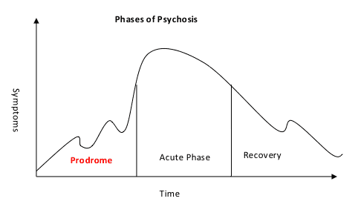

Quick rise towards phase. Fluctuates a bit. Recovery phase is slower.

First phase.

1. Disconnected.
2. Alone.
3. Suspicious.
4. Brighter or sounds become louder.
5. Difficulty on focusing on what they are hearing.
6. Difficulty screening out distracting information and sensation.
7. Difficult to keep track of things.

Second phase.

1. Hallucinations.
2. Delusions.
3. Very odd speech behaviours.